Parent/ Carer Information
Children & Young People Service
Broad General Education (Primary 1 – S3)
Briefing Paper 1 – Health & Wellbeing | Guidance for parents and carers on wellbeing and the provision of home learning activities  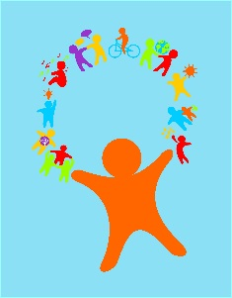  During this time, the wellbeing of your child is of utmost importance, and should be carefully balanced with educational activities. We recognise that many families may be under stress, and this guidance is intended to reassure and help you decide what is best for your family when it comes to home learning activities.  1.Do not expect your child to engage in a ‘full timetable’ as they would do in school. It won’t be possible to replicate a full school timetable. Give yourself and your child permission to accept this.  2.Do have a plan/ routine in place. This helps children to feel calmer. Follow a simple daily schedule including key times to engage in some home-learning activities. Try to involve everyone in the house in planning this schedule together.  3.As a parent, you must decide what amount of home-learning is best for you and your family. No activities are compulsory. As a parent you may be juggling the commitments of your own job and family life, and it’s about getting the balance right in the home.  4.Don’t worry if the routine isn’t perfect – Remember, this isn’t a normal situation. If you find that planning and sticking to the routine is causing more stress, friction or conflict, then it’s fine to be more ‘free-flow’. Be guided by the activities your family enjoys.  5.Try to do activities that help your family spend time together, enjoy your relationships and have fun. Play is fundamental to child’s wellbeing and development (children of all ages!) and is a great way to reduce stress in adults too. So long as you are all well and able to do so, have fun and play  6.Don’t worry too much about academic progress at this time, and avoid putting children under pressure. Most parents/carers are not teachers and you are not expected to teach your children new school work. New learning best takes place when pupils are relaxed and happy, rather than at times of stress and uncertainty. It is more important to reassure your children and spend time enjoying shared activities.  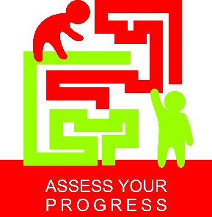  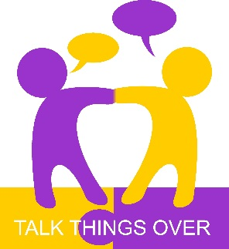  - A sense of success and achievement is, nevertheless, an important factor in wellbeing – so help your child and young person choose activities where they are likely to experience success. If the work provided seems too hard for your child or young person, then it is okay to just leave it. You may decide to come back to it at a different time.  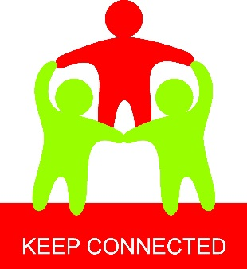  - Try to help your child to stay connected with school staff. Depending on the age or stage of your child or young person, this might be through video conferences arranged by the class teacher, by class blogs, through the school’s social media page or by emailing teachers. Maintaining key relationships is important where possible.  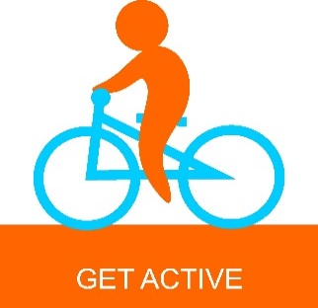  - Similarly, try to help your child stay connected to their friends. Most children see their friends nearly every day of the week and so not being in contact with them for some time might be upsetting. Try to encourage or help your child connect with their friends through voice calls, video calls or messages on mobile phones.  - Try and get some exercise for all the family. There is strong evidence that physical activity supports our mental wellbeing. Opportunities are limited in the current situation but take advantage of what is available and relevant to the interests of your child and family.  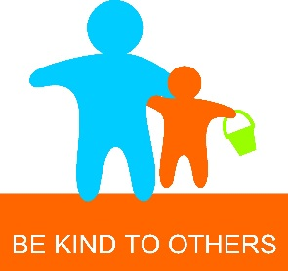  Primary school children and S1/2 young people in secondary schools have been using the Building Resilience materials to support wellbeing. Children and young people should be familiar with the character ‘Skipper’. The resource follows Skipper along his ‘River of Life’, and provides 10 practical strategies that we can all use when we experience difficulties, frustrations and challenging times. The illustrations on this briefing are from this Building Resilience resource.  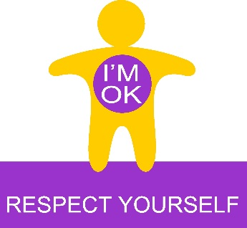  Finally, if you have any worries or concerns about how your child or young person is managing please contact your school Hub. They will get in touch with staff from your own school staff, and get back to you. We are here to help. Hub contact details:  Eyemouth Primary - 01890750692 Langlee Primary - 01896664174  Duns Primary - 01361884050 Halyrude Primary – 0172172023  Philiphaugh Primary -01750721774 Melrose Primary – 01896 822103  Wilton Primary – 01450372075 Broomlands Primary – 01573223070  Additional helpful information about talking to your child or young person about Coronavirus may be found at the link below: https://www.bps.org.uk/news-and-policy/bps-highlights-importance-talking-children-about-coronavirus

