Leading School Improvement 2020-21
Meaningful Learning Year 3
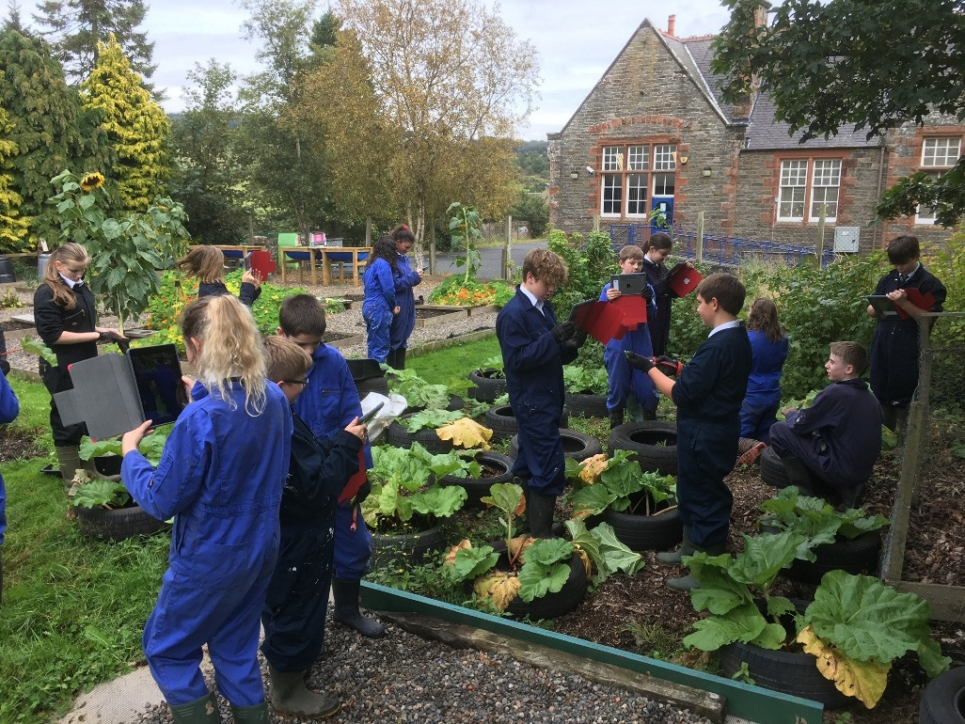
DRAFT

School Improvement 2020-21

- Raising Attainment
-Learning and Teaching: Moving from Satisfactory to Good through Consistent Pedagogy- Feedback and Inspirelearning (with a continued focus on Learning Intentions and Success Criteria)
- My Journey (Comprehensive Learning Overview): Qualifications, Skills and Values
- Senior Phase: Every student achieves 5+ Qualifications
- 5@5 Ambition Target
- Tracking and Addressing the Covid Gap/Absence
- Developing Employability
- Developing our Golden Skills and Leadership Pathways incl. accreditation and Partnership working including family learning.
- Tracking Achievement from S1: Qualifications, Skills and Values

- Health and Wellbeing

- A Nurturing Approach
- Health and Wellbeing- with a focus on mental Health
- Relentless Routines with a particular focus on closing the loop and phone calls home

Classroom Leaders
- Learning and Teaching- Collaborative Professional Development
Focus on Feedback (and maintaining focus on Learning Intentions and Success Criteria)
Maintained focus on our Positive Relationships Framework Relentless Routines
Meet and Greet
First Attention to positive conduct
Praise Postcard minimum X1 weekly
School Improvement Groups 2020-21
Learning and Teaching
VIA Positive Relationships/H&W
Golden Skills/Employability
School Operational Groups 2020-21
House System
Leadership and S6 Committees
Extra Curricular
Communications/Events
Staff H&W

Praise phone call x1 weekly
Concern Calls Home
Restorative Approaches and ‘Closing the Loop’

- Nurture
NURTURE 2020-21 (SBC Improvement Priority)

- School Improvement Group (Collaborative Enquiry)
and School Operational Groups

Working with others to have a whole school impact

Faculty Leaders – Curriculum and Pastoral

- Learning and Teaching Improvement: QA for consistency
- Nurture
- Ambition for all: Every Student achieves 5xQualifications (Risk Matrix)
- Developing the Meaningful Curriculum – Progression for all
- S3 Challenge and accreditation/banking
- Recording and Celebrating Wider Achievement

Senior Leadership Team – Roles and Remits

24th April 2019 Staff Meeting Feedback:  -whole School Termly Focus on each Pedagogical Key Area  - establish shared understanding of best practice  - develop consistent high quality practice | Term 1: Positive Rel + Learning Intentions and Success Criteria  Term 2: Positive Rel + Feedback  Term 3: Positive Rel + Students Leading Learning
Tracking the Impact of our Self Evaluation/Professional Dev | Inservice Workshop
Self Evaluation/Peer Support: Learning Visit Policy | Inservice Workshop  Our Journey  2019-20
Restorative Practice Training | First Day Inservice training? Follow-up  Pupil Training
Sharing Reading/Good Practice | Inservice Workshop  Ongoing opportunity
3rd May 2019 Inservice Workshops
1. Tracking Impact- Self Evaluation (Tricia Barker, Yvonne Roy)
2. Learning Visit Policy (Jenna Swan, Alan Aiken)
3. Sharing Reading/Good Practice (Sam McHenry, Chris Dolan)
4. Inservice Day Structure (Laura Thomson, Claire Poole)
Workshop Leaders’ Feedback 15th May 2019
- Learning Visit Policy re-designed
- Self Evaluation approach + Lesson Planner designed
- Sharing Practice Programme 2019-20
- Inservice structure designed

Session 2019-20 Feedback (32 staff responded May 2020)
- 97% staff felt involved in developing the approach
- 93% staff feel relentless routines have had positive impact in class
- 87% staff feel relentless routines have had positive impact across school
- 100% staff feel knowledge/understanding/confidence in key pedagogy has improved
- 90% staff have evidence that L&T development has had positive impact on students
- 80% staff feel we should maintain the focus on Feedback (+LI/SC)

Staff Meeting 19th June 2019

- Agree Termly Focus and Calendar
- Agree Approach
- Share Reading for Inservice Aug 2019

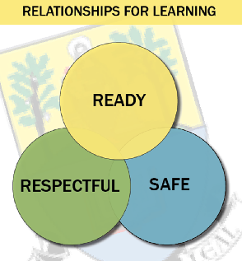
Selkirk High School: Learning Planner
Success Criteria
What are we looking for? How can we prove that we have learned today?
Success criteria need to be manageable and as explicit as possible.
Are success criteria appropriately challenging?
Feedback (formal or informal) must link back to success criteria.

Learning Intention
Does LI make learning relevant to all?
Focus is on LEARNING NOT DOING

Prior Knowledge
How do I check their current knowledge?
Which students are on the Risk Matrix- how can I support them? How will I work with ANAs to support students?

Learning Activity
All pupils must learn in every lesson, every day!

Feedback
How does Feedback support learning and learners?

Plenary
What did they learn today- are they aware of this?
What’s the ‘end and send’ strategy?
Practise and Metacognition
How do students apply feedback and make improvements stick?

Check Understanding
How will you check all students?
Do you have an inclusive questioning strategy?

Selkirk High School: Learning Planner
Success Criteria
What are we looking for? How can we prove that we have learned today?
Success criteria need to be manageable and as explicit as possible.
Are success criteria appropriately challenging?
Feedback (formal or informal) must link back to success criteria.
- Simple Language with use of command words eg ‘I can describe, evaluate, calculate, etc
- Referred to clearly in Feedback

Learning Intention
Does LI make learning relevant to all?
Focus is on LEARNING NOT DOING

Keep it Simple- Use of Know, be able to, understand
- Flexibility around how/when Lis are introduced is encouraged!
- Skills focus where appropriate
- Refer to throughout and at end of lesson

Prior Knowledge
How do I check their current knowledge?
Which students are on the Risk Matrix- how can I support them? How will I work with ANAs to support students?

We have to establish what pupils know and where the gaps are- Examples:
- Learning Logs, and Organisers: mind maps, essay plans, checklists, tables, venns, diagrams.
- Quiz
- Start with an end of topic test?

Learning Activity
All pupils must learn in every lesson, every day!
- Appropriate Pace and Challenge and support is experienced by all
- Questioning is used to make all students think hard
- Discussion is used to develop thinking and check understanding
- Pupils take leading roles in discussion and supporting each other to learn
- Resources are high quality and clear and relate explicitly to the learning intentions
- Modelling and scaffolding supports learning

Plenary
What did they learn today- are they aware of this?
What’s the ‘end and send’ strategy?

A final check of understanding – which refers back to Learning Intention and success criteria- can be motivational for students who recognise their own progress.

-Exit pass, mini-whiteboards
-Summary statements, quick quizzes.
- Q and A; quick response questioning strategy.

Practise
How do students apply feedback and make improvements stick?

Students need to practise to make their learning permanent
- Daily quizzes, pupil-led recaps; retrieval homework
- Regular ‘chunked’ practise
- Students move from Guided to Supported to Independent practice

Feedback and Metacognition
How does Feedback support learning and learners?
Feedback is explicitly focused on shared success criteria
Feedback is pupil friendly and pupils understand what they need to do to improve
Feedback strategies are used throughout the lesson
Pupils have time and opportunity to apply feedback
Pupils feedback informs teaching
Immediacy of feedback is a feature of my teaching
Metacognition: when students understand themselves as learners and plan their learning accordingly eg
- Highlight corrections, revision planners and graphic organisers and Learning Logs.

Check Understanding
How will you check all students?
Do you have an inclusive questioning strategy?
Learning is really accelerated when teachers check learning within lessons and make changes accordingly.
Daily, weekly, monthly reviews
Active assessment strategies are used eg
- Mini whiteboards, quizzes
- Questioning strategy to include all learners (are pupils listening to each other?)
- 1:1 with students
- Self and Peer Assessment explicitly linked to SC

Meaningful Learning: SHS Learning Intentions Dashboard
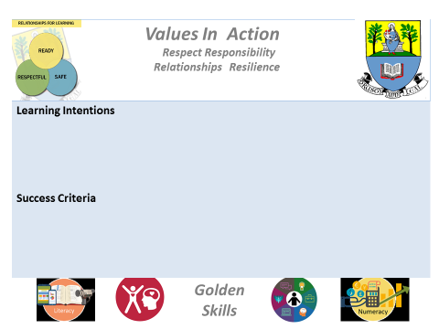
2017-18 SENIOR PHASE CHOICES | 2018-20 SENIOR PHASE CHOICES | 2020-21 SENIOR PHASE CHOICES
Admin and IT  Art and Design  Art and Design: Expressive Activity with Scottish Context(N3)  Biology (+AH)  Business Management  Chemistry (+AH)  Design and Manufacture  Drama  English (+AH)  Environmental Science (N4)  French(+AH)  Geography  German  Graphic Communication  Health and Food Technology  Hospitality (N4,5)  History  Human Biology  Mathematics(+AH)  Modern Studies  Music(+AH)  Performing Music on One Instrument or Voice (H, AH)  PE  Physics(+AH)  Practical Woodworking (N4,5)  RME (H)  Science (N3)  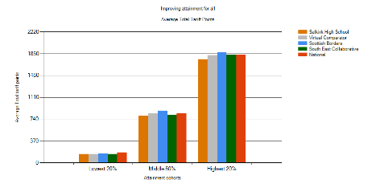  Spanish (+AH) | Art and Design  Building a Meaningful Curriculum at SHS: Qualifications, Skills and Values  Art and Design: Expressive Activity with Scottish Context(N3)  Biology (+AH)  Business Management (N5/H)  Chemistry (+AH)  Design and Manufacture  Drama  English (+AH)  Environmental Science (N4)  Geography  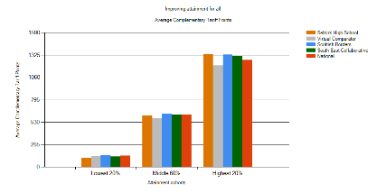  Graphic Communication  Health and Food Technology (H)  Hospitality (N4,5)  History (+  Human Biology (+AH)  Mathematics(+AH)  Modern Studies  Music(+AH)  Performing Music on One Instrument or Voice (H, AH)  PE  Physics  Practical Woodworking (N4,5)RME (H)  Science (N3)  Spanish (+AH)  Photography (H)  Personal Finance (SCQF 4)  Employability (SCQF 4/5)  Personal Achievement Award  S6 Leadership Award  Youth Achievement Award  2019-2020 Leadership and Language N4  2019-2020 Travel and Tourism  Work Placement Award | Art and Design (+AH)  Art and Design: Expressive Activity with Scottish Context(N3)  Biology (+AH)  Business Management N5/H)  Chemistry (+AH)  Design and Manufacture  Drama (+AH)  English (+AH)  Environmental Science (N4)  Geography  Graphic Communication  Health and Food Technology (H)  Hospitality (N4,5)  History (+AH)  Human Biology (+AH)  Mathematics(+AH)  Modern Studies  Music(+AH)  Performing Music on One Instrument or Voice (H, AH)  PE  Physics  Practical Woodworking (N4,5)  Science (N3)  Spanish (+AH)  Photography (N5 NPA and H)  Personal Finance and PC Passport (SCQF 4)  Employability (SCQF 4/5)  Personal Achievement Award (SCQF 3/4)  Personal Development Award (SCQF 3/4)  S6 Leadership Award (SCQF 5/6)  Youth Achievement Award  Leadership and Language N4  Health Sector N4/5  Environmental Science N5  Rural Skills (N4)  Horse Care (N4)  Readiness for Work; Saltire Awards etc  Application of Maths N5  Cyber Security NPA Level 4/5  John Muir Award  Work Placement Award (S4)  Dynamic Youth Awards

